**Title**: Perception of social consensus but not moral conviction affects support for universal health care

**Authors**: Sean X. Duan; Victoria A. Shaffer

**Word Count**: 375/375

**Purpose**: The overwhelming majority of modern countries provide some form of Universal Health Care (UHC), except for the United States. Additionally, recent research shows that health-care beliefs are becoming more polarized. We aimed to learn if behavioral science theory on the formation and changing of polarized beliefs applied in the context of American support for UHC. Across three studies, we manipulated perceived levels of social consensus and moral conviction.

**Method**: Two samples of college students (Study 1 N = 505; Study 2 N = 491) rated their level of support for UHC in America on a 0-100 slider bar, both before and after the intervention. In Study 2, participants additionally rated their perception of moral conviction. Using a between subjects’ design, in Study 1, participants were exposed to survey information that purported to depict public support for UHC (83%, or 43%) intended to manipulate social consensus; Study 2 looked to see if perception of moral conviction interacted with the effect of social consensus. We hypothesized that social consensus would affect support for UHC, and additionally, that decreases in moral conviction would increase the effectiveness of the social consensus condition (an interaction).

**Results**: In Study 1, the social consensus manipulation had a significant effect on support for UHC, P<.05; Support for UHC increased in the ‘high’ social consensus condition and decreased in the ‘low’ social consensus condition. In Study 2, we replicated the main effect of social consensus affecting support for UHC, P<.05; however, we did not detect significant interaction with moral conviction.

**Conclusions**: Perception of social consensus leads to significant increases or decreases of support for UHC in college students. Furthermore, increasing or decreasing the saliency of the moral element does not seem to interact with the effects of social influence, at least in the context of universal health care. Given that the influence of outside society is so strong at affecting support for UHC, clearly advertising to the public that the majority of society is in agreement with UHC may be an effective strategy to promote policy change.

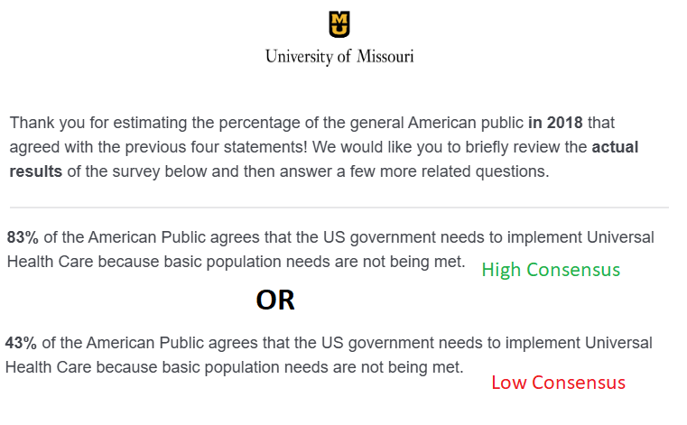

Figure 1. ‘High’ and ‘Low’ social consensus manipulation used for Study 1 & 2